UNITED STATES
SECURITIES AND EXCHANGE COMMISSION
WASHINGTON, D.C. 20549

FORM 8-K

CURRENT REPORT
Pursuant to Section 13 or 15(d) of the Securities Exchange Act of 1934
Date of Report (Date of earliest event reported): September 15, 2026

VERADIGM INC.
(Exact name of Registrant as Specified in Its Charter)

Delaware |  |  | 000-32085 | 36-4392754
(State or Other Jurisdiction  of Incorporation) |  |  | (Commission File Number) | (IRS Employer  Identification No.)
222 Merchandise Mart
Chicago, Illinois |  |  |  | 60654
(Address of Principal Executive Offices) |  |  |  | (Zip Code)

Registrant’s Telephone Number, Including Area Code: 800 334-8534

(Former Name or Former Address, if Changed Since Last Report)

Check the appropriate box below if the Form 8-K filing is intended to simultaneously satisfy the filing obligation of the registrant under any of the following provisions:
☐Written communications pursuant to Rule 425 under the Securities Act (17 CFR 230.425)
☐Soliciting material pursuant to Rule 14a-12 under the Exchange Act (17 CFR 240.14a-12)
☐Pre-commencement communications pursuant to Rule 14d-2(b) under the Exchange Act (17 CFR 240.14d-2(b))
☐Pre-commencement communications pursuant to Rule 13e-4(c) under the Exchange Act (17 CFR 240.13e-4(c))
Securities registered pursuant to Section 12(b) of the Act:
Title of each class |  | Trading  Symbol(s) |  | Name of each exchange on which registered
Common Stock, par value $0.01 per share |  | MDRX |  | N/A (OTC Expert Market)
Indicate by check mark whether the registrant is an emerging growth company as defined in Rule 405 of the Securities Act of 1933 (§ 230.405 of this chapter) or Rule 12b-2 of the Securities Exchange Act of 1934 (§ 240.12b-2 of this chapter).
Emerging growth company ☐
If an emerging growth company, indicate by check mark if the registrant has elected not to use the extended transition period for complying with any new or revised financial accounting standards provided pursuant to Section 13(a) of the Exchange Act. ☐

Item 7.01 Regulation FD Disclosure.
As previously announced, the Company will present at the 2026 Jefferies Healthcare Services and Technology Conference in Nashville, Tennessee on September 15, 2026 and will participate in the Deutsche Bank 2026 Healthcare Summit in New York, New York on September 16, 2026. A copy of the Company’s presentation is furnished as Exhibit 99.1. The Company intends to use this presentation at other investor conferences.
The information furnished pursuant to this Item shall not be deemed “filed” for purposes of Section 18 of the Securities Exchange Act of 1934, as amended (the “Exchange Act”), or incorporated by reference in any filing under the Securities Act of 1933, as amended, or the Exchange Act.

Item 9.01 Financial Statements and Exhibits.
(d) Exhibits.
Exhibit
No.
99.1 |  | Copy of Veradigm Inc. presentation slides
104 |  | Cover Page Interactive Data File (embedded within the Inline XBRL document)

SIGNATURES
Pursuant to the requirements of the Securities Exchange Act of 1934, the registrant has duly caused this report to be signed on its behalf by the undersigned hereunto duly authorized.

 |  |  | VERADIGM INC.
 | September 15, 2026 | By: | /s/ Eric Jacobson
Eric Jacobson
Senior Vice President, Interim General Counsel &
Corporate Secretary

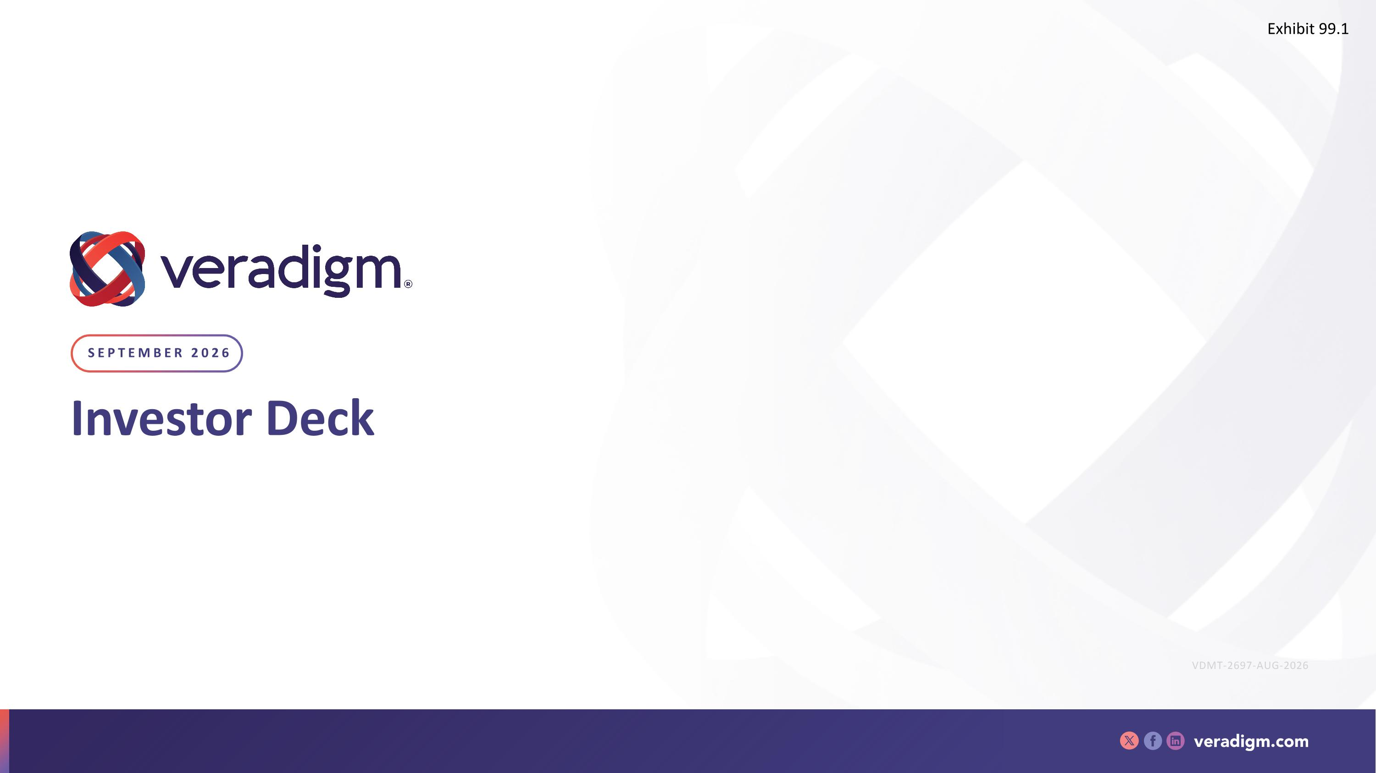
Investor Deck September 2026 VDMT-2697-AUG-2026 Exhibit 99.1

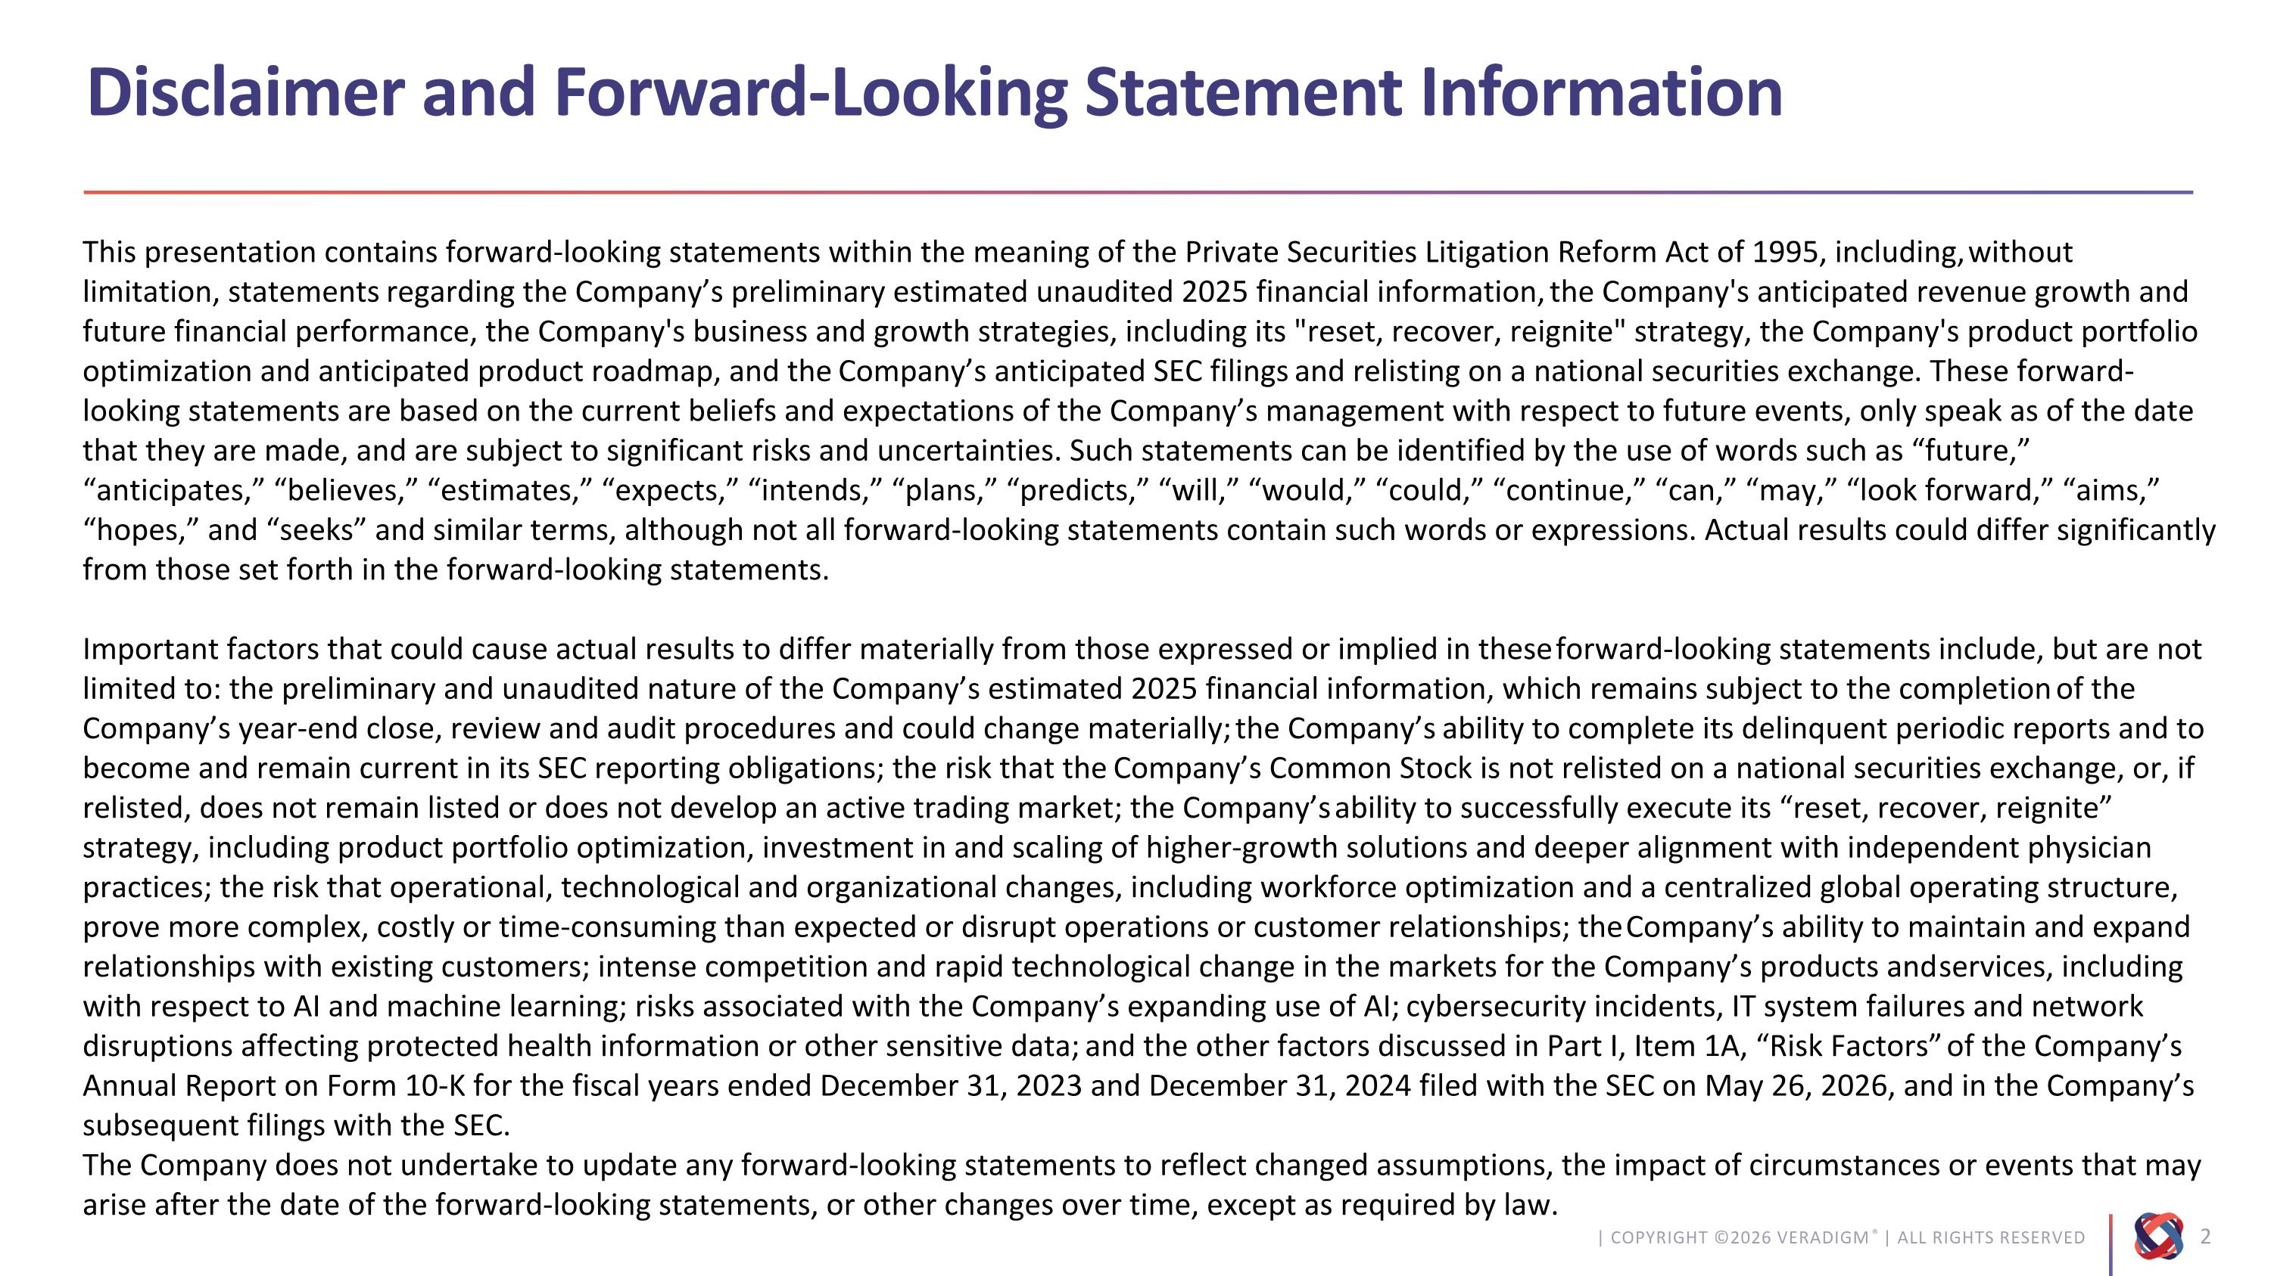
Disclaimer and Forward-Looking Statement Information This presentation contains forward-looking statements within the meaning of the Private Securities Litigation Reform Act of 1995, including, without limitation, statements regarding the Company’s preliminary estimated unaudited 2025 financial information, the Company's anticipated revenue growth and future financial performance, the Company's business and growth strategies, including its "reset, recover, reignite" strategy, the Company's product portfolio optimization and anticipated product roadmap, and the Company’s anticipated SEC filings and relisting on a national securities exchange. These forward-looking statements are based on the current beliefs and expectations of the Company’s management with respect to future events, only speak as of the date that they are made, and are subject to significant risks and uncertainties. Such statements can be identified by the use of words such as “future,” “anticipates,” “believes,” “estimates,” “expects,” “intends,” “plans,” “predicts,” “will,” “would,” “could,” “continue,” “can,” “may,” “look forward,” “aims,” “hopes,” and “seeks” and similar terms, although not all forward-looking statements contain such words or expressions. Actual results could differ significantly from those set forth in the forward-looking statements. Important factors that could cause actual results to differ materially from those expressed or implied in these forward-looking statements include, but are not limited to: the preliminary and unaudited nature of the Company’s estimated 2025 financial information, which remains subject to the completion of the Company’s year-end close, review and audit procedures and could change materially; the Company’s ability to complete its delinquent periodic reports and to become and remain current in its SEC reporting obligations; the risk that the Company’s Common Stock is not relisted on a national securities exchange, or, if relisted, does not remain listed or does not develop an active trading market; the Company’s ability to successfully execute its “reset, recover, reignite” strategy, including product portfolio optimization, investment in and scaling of higher-growth solutions and deeper alignment with independent physician practices; the risk that operational, technological and organizational changes, including workforce optimization and a centralized global operating structure, prove more complex, costly or time-consuming than expected or disrupt operations or customer relationships; the Company’s ability to maintain and expand relationships with existing customers; intense competition and rapid technological change in the markets for the Company’s products and services, including with respect to AI and machine learning; risks associated with the Company’s expanding use of AI; cybersecurity incidents, IT system failures and network disruptions affecting protected health information or other sensitive data; and the other factors discussed in Part I, Item 1A, “Risk Factors” of the Company’s Annual Report on Form 10-K for the fiscal years ended December 31, 2023 and December 31, 2024 filed with the SEC on May 26, 2026, and in the Company’s subsequent filings with the SEC. The Company does not undertake to update any forward-looking statements to reflect changed assumptions, the impact of circumstances or events that may arise after the date of the forward-looking statements, or other changes over time, except as required by law.

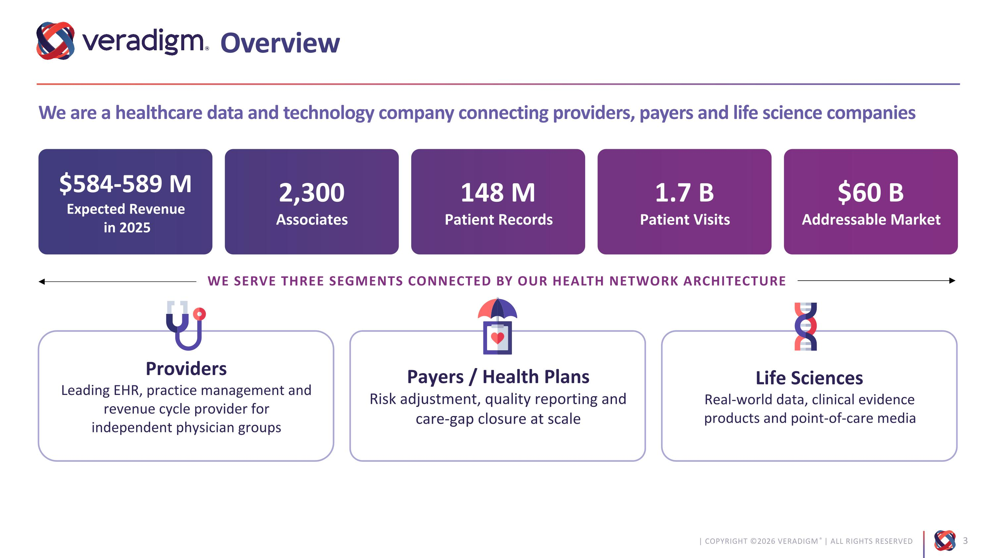
Overview We are a healthcare data and technology company connecting providers, payers and life science companies $584-589 M Expected Revenue? in 2025 2,300 Associates 1.7 B Patient Visits 148 M Patient Records $60 B Addressable Market WE SERVE THREE SEGMENTS CONNECTED BY OUR HEALTH NETWORK ARCHITECTURE Providers Leading EHR, practice management and revenue cycle provider for?independent physician groups Payers / Health Plans Risk adjustment, quality reporting and care-gap closure at scale Life Sciences Real-world data, clinical evidence products and point-of-care media

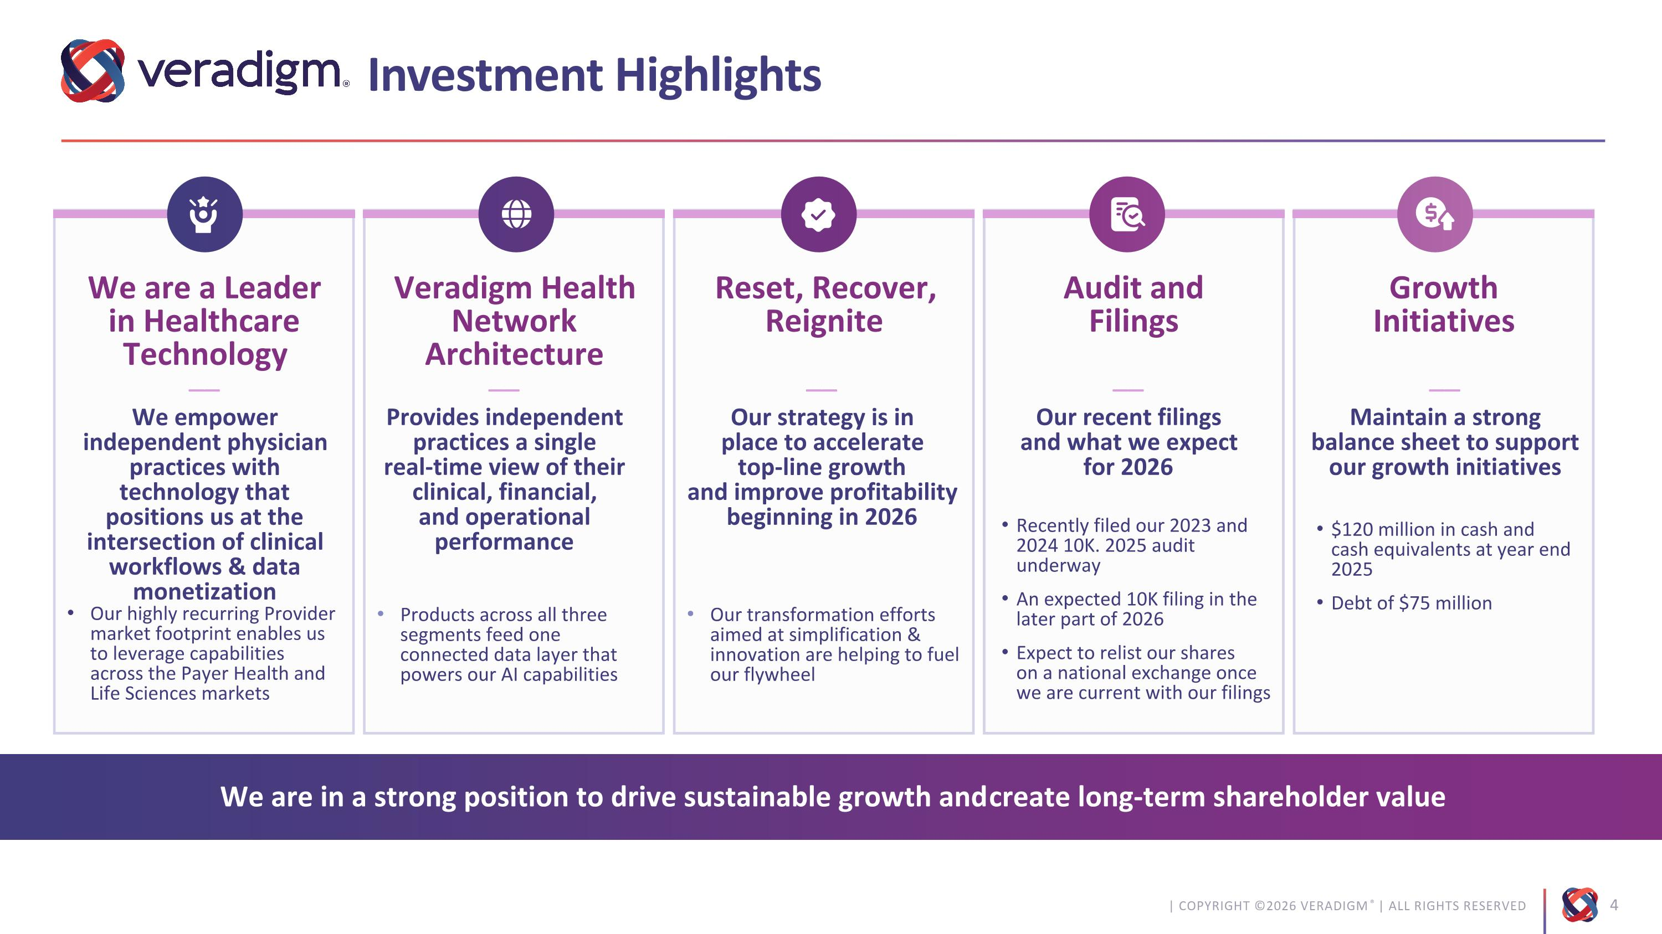
Veradigm Health Network Architecture We are a Leader in Healthcare Technology Reset, Recover, Reignite Audit and?Filings Growth?Initiatives Investment Highlights We are in a strong position to drive sustainable growth and create long-term shareholder value Our transformation efforts aimed at simplification & innovation are helping to fuel our flywheel Our highly recurring Provider market footprint enables us to leverage capabilities across the Payer Health and Life Sciences markets Products across all three segments feed one connected data layer that powers our AI capabilities Recently filed our 2023 and 2024 10K. 2025 audit underway An expected 10K filing in the later part of 2026 Expect to relist our shares ?on a national exchange once we are current with our filings $120 million in cash and ?cash equivalents at year end 2025 Debt of $75 million ––?Provides independent practices a single ?real-time view of their clinical, financial, ?and operational performance ––?We empower independent physician practices with technology that positions us at the intersection of clinical workflows & data monetization ––?Our strategy is in ?place to accelerate ?top-line growth ?and improve profitability ?beginning in 2026 ––?Our recent filings ?and what we expect ?for 2026 ––?Maintain a strong balance sheet to support our growth initiatives

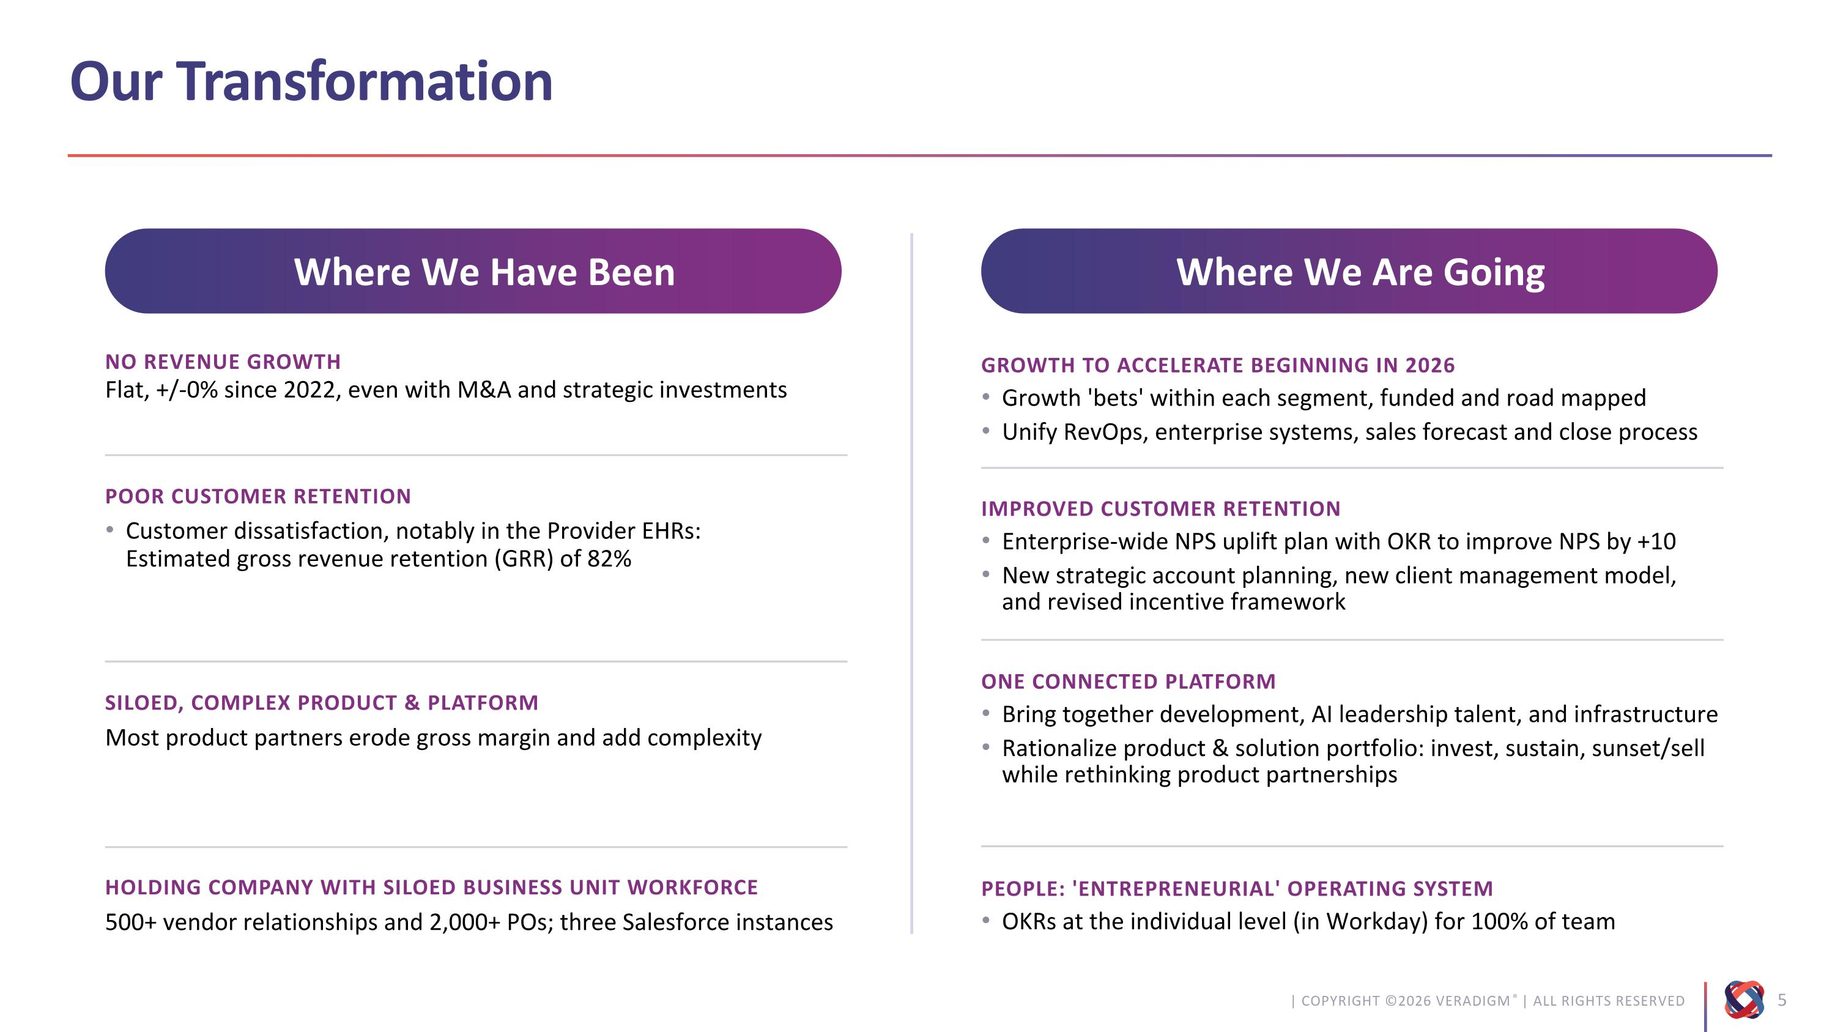
Our Transformation Flat, +/-0% since 2022, even with M&A and strategic investments NO revenue GROWTH POOR CUSTOMER RETENTION Most product partners erode gross margin and add complexity SILOED, COMPLEX PRODUCT & PLATFORM 500+ vendor relationships and 2,000+ POs; three Salesforce instances HOLDING COMPANY WITH SILOED BUSINESS UNIT WORKFORCE Growth 'bets' within each segment, funded and road mapped Unify RevOps, enterprise systems, sales forecast and close process GROWTH TO ACCELERATE BEGINNING IN 2026 Enterprise-wide NPS uplift plan with OKR to improve NPS by +10 New strategic account planning, new client management model, ?and revised incentive framework Improved Customer Retention Bring together development, AI leadership talent, and infrastructure Rationalize product & solution portfolio: invest, sustain, sunset/sell while rethinking product partnerships One Connected Platform OKRs at the individual level (in Workday) for 100% of team People: 'entrepreneurial' operating system Customer dissatisfaction, notably in the Provider EHRs: ?Estimated gross revenue retention (GRR) of 82% Where We Have Been Where We Are Going

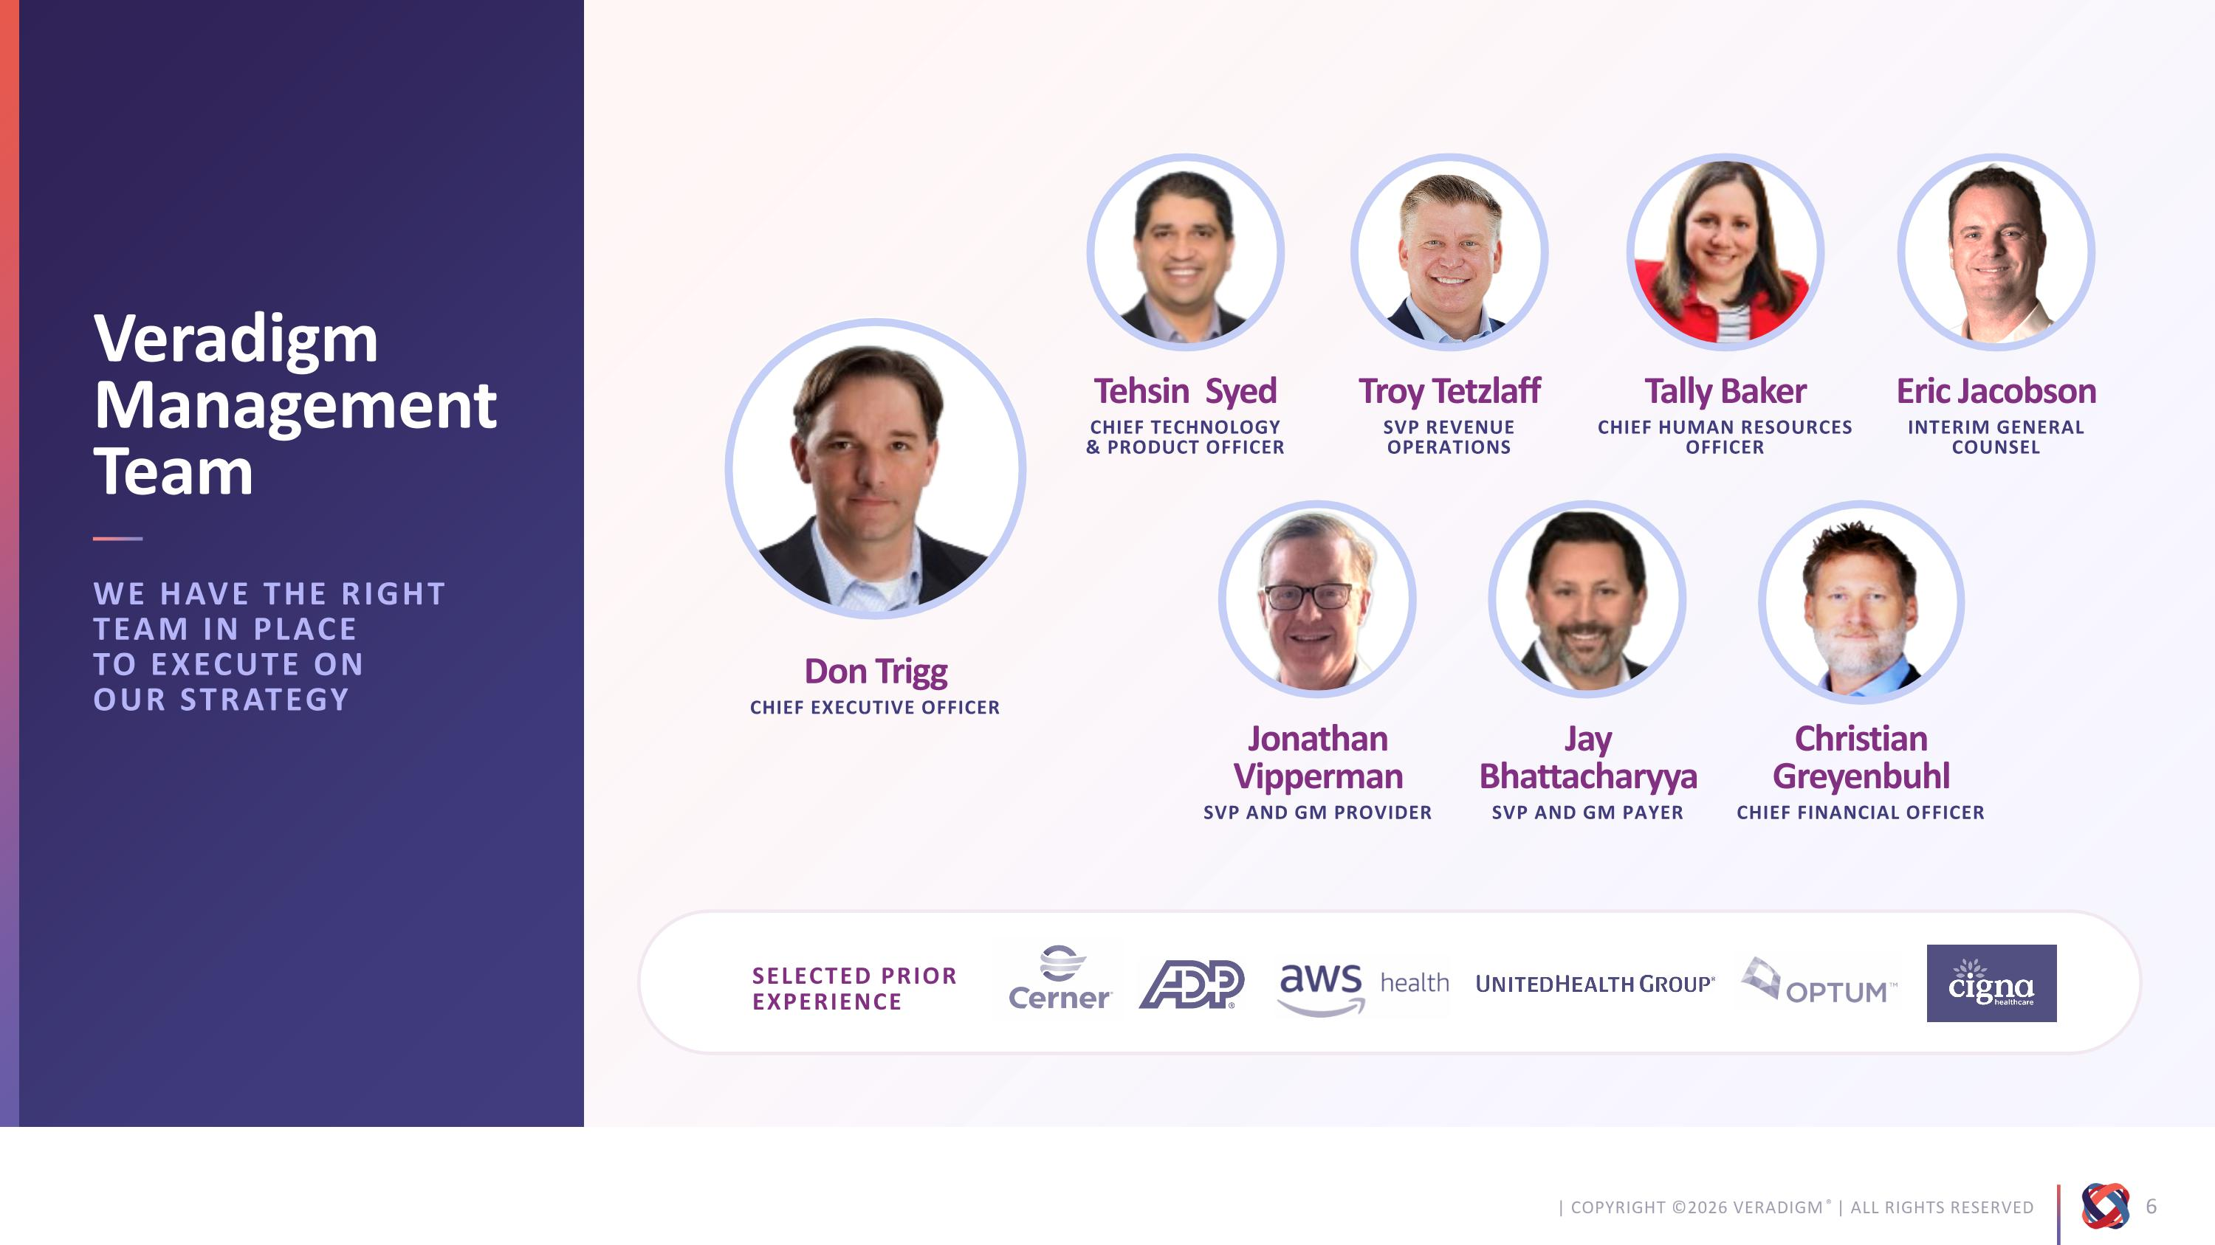
Tehsin Syed CHIEF TECHNOLOGY ?& PRODUCT OFFICER Veradigm Management Team SELECTED PRIOR EXPERIENCE Troy Tetzlaff SVP REVENUE OPERATIONS Tally Baker Chief Human Resources Officer Eric Jacobson Interim General Counsel Jonathan Vipperman SVP and GM Provider Jay Bhattacharyya SVP and GM Payer Don Trigg Chief Executive Officer Christian ?Greyenbuhl Chief Financial Officer WE HAVE THE RIGHT TEAM IN PLACE ?TO EXECUTE ON ?OUR STRATEGY

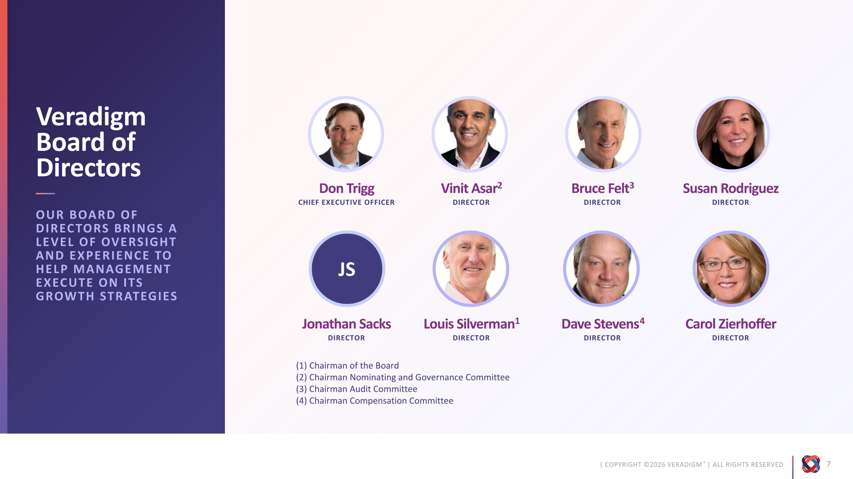
Vinit Asar2 director Veradigm Board of Directors Bruce Felt3 director Susan Rodriguez director Jonathan Sacks director Louis Silverman1 director Don Trigg Chief Executive Officer Carol Zierhoffer director OUR BOARD OF DIRECTORS BRINGS A LEVEL OF OVERSIGHT AND EXPERIENCE TO ?HELP MANAGEMENT EXECUTE ON ITS GROWTH STRATEGIES Dave Stevens4 director JS (1) Chairman of the Board (2) Chairman Nominating and Governance Committee (3) Chairman Audit Committee (4) Chairman Compensation Committee

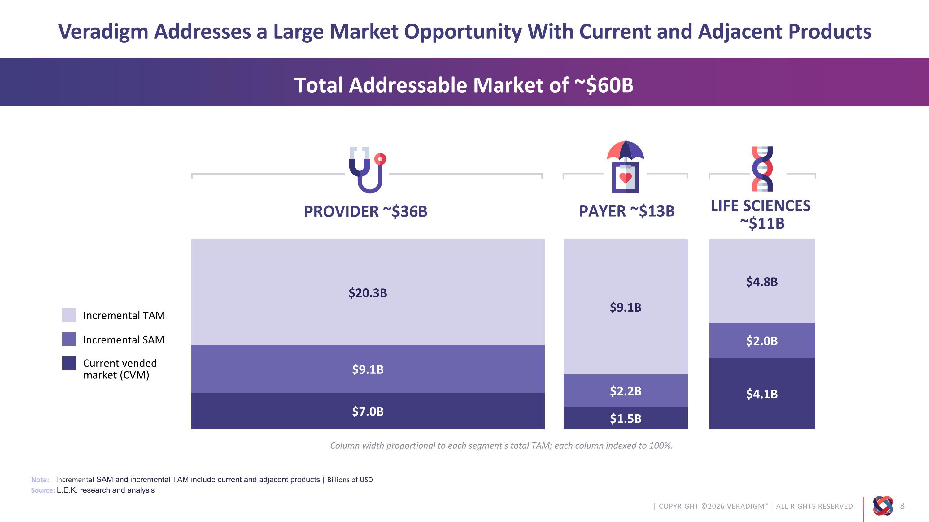
Veradigm Addresses a Large Market Opportunity With Current and Adjacent Products Note: Incremental SAM and incremental TAM include current and adjacent products | Billions of USD Source: L.E.K. research and analysis $20.3B $9.1B $7.0B $9.1B $2.2B $1.5B $4.8B $2.0B $4.1B Incremental TAM Incremental SAM Current vended ?market (CVM) Column width proportional to each segment's total TAM; each column indexed to 100%. Total Addressable Market of ~$60B PROVIDER ~$36B PAYER ~$13B LIFE SCIENCES ?~$11B

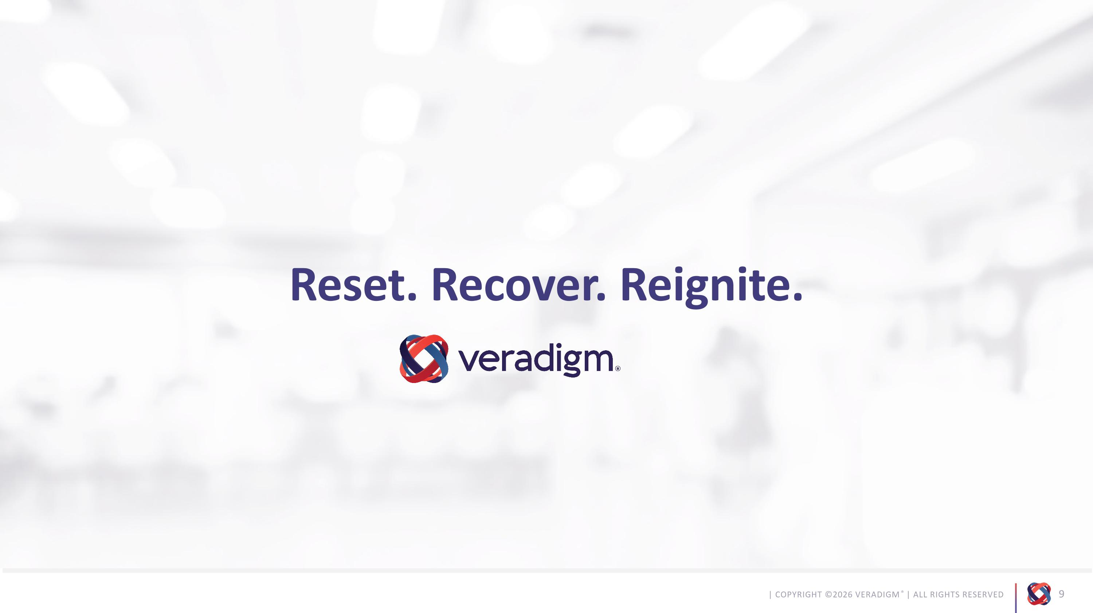
Reset. Recover. Reignite.

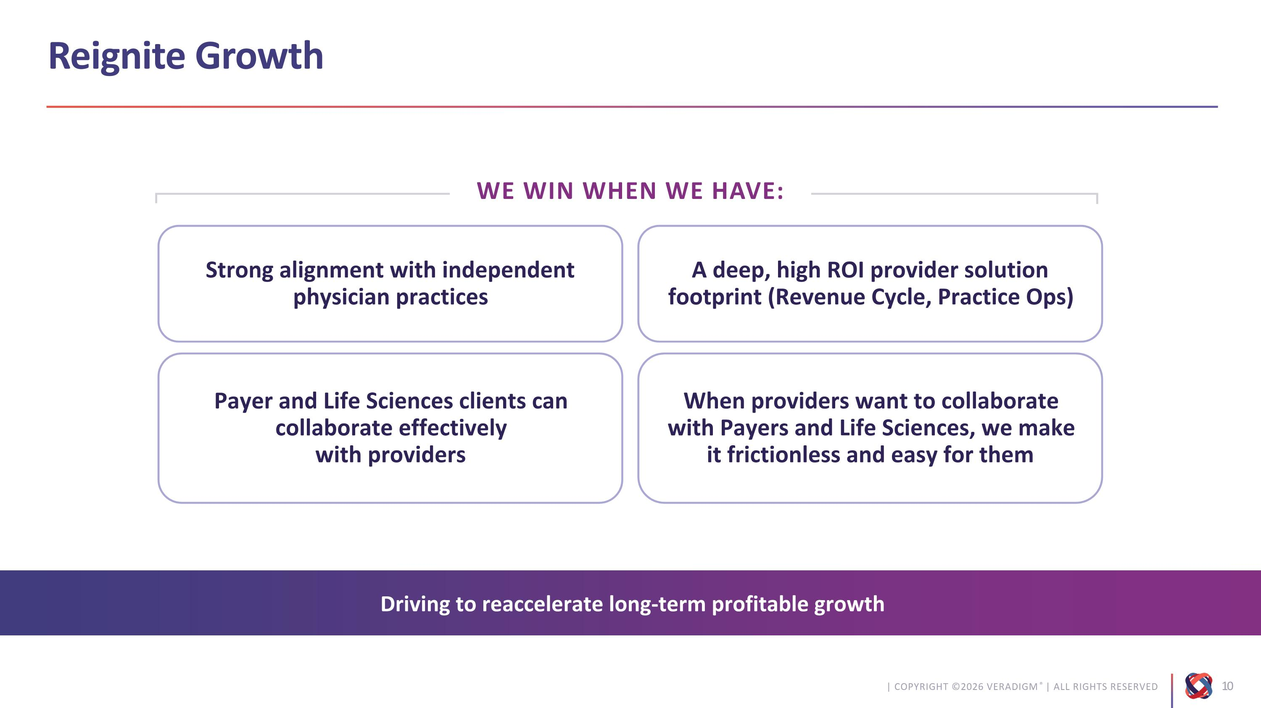
Reignite Growth Driving to reaccelerate long-term profitable growth WE WIN WHEN WE HAVE: Strong alignment with independent physician practices A deep, high ROI provider solution footprint (Revenue Cycle, Practice Ops) Payer and Life Sciences clients can collaborate effectively ?with providers When providers want to collaborate with Payers and Life Sciences, we make it frictionless and easy for them

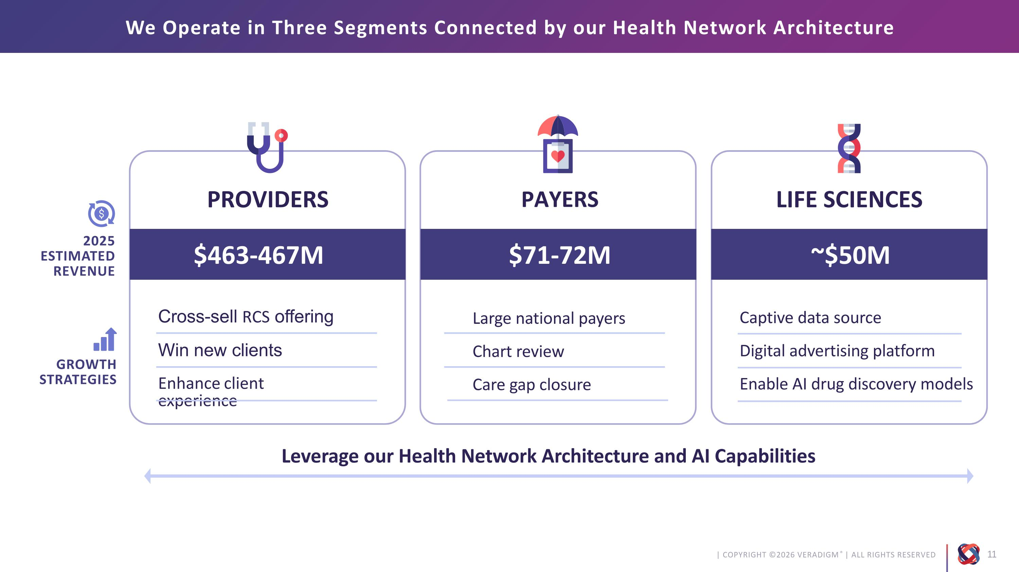
PROVIDERS PAYERS LIFE SCIENCES We Operate in Three Segments Connected by our Health Network Architecture $463-467M $71-72M ~$50M 2025 ESTIMATED REVENUE GROWTH?STRATEGIES Cross-sell RCS offering Win new clients Enhance client experience Captive data source Digital advertising platform Enable AI drug discovery models Leverage our Health Network Architecture and AI Capabilities Large national payers Chart review Care gap closure

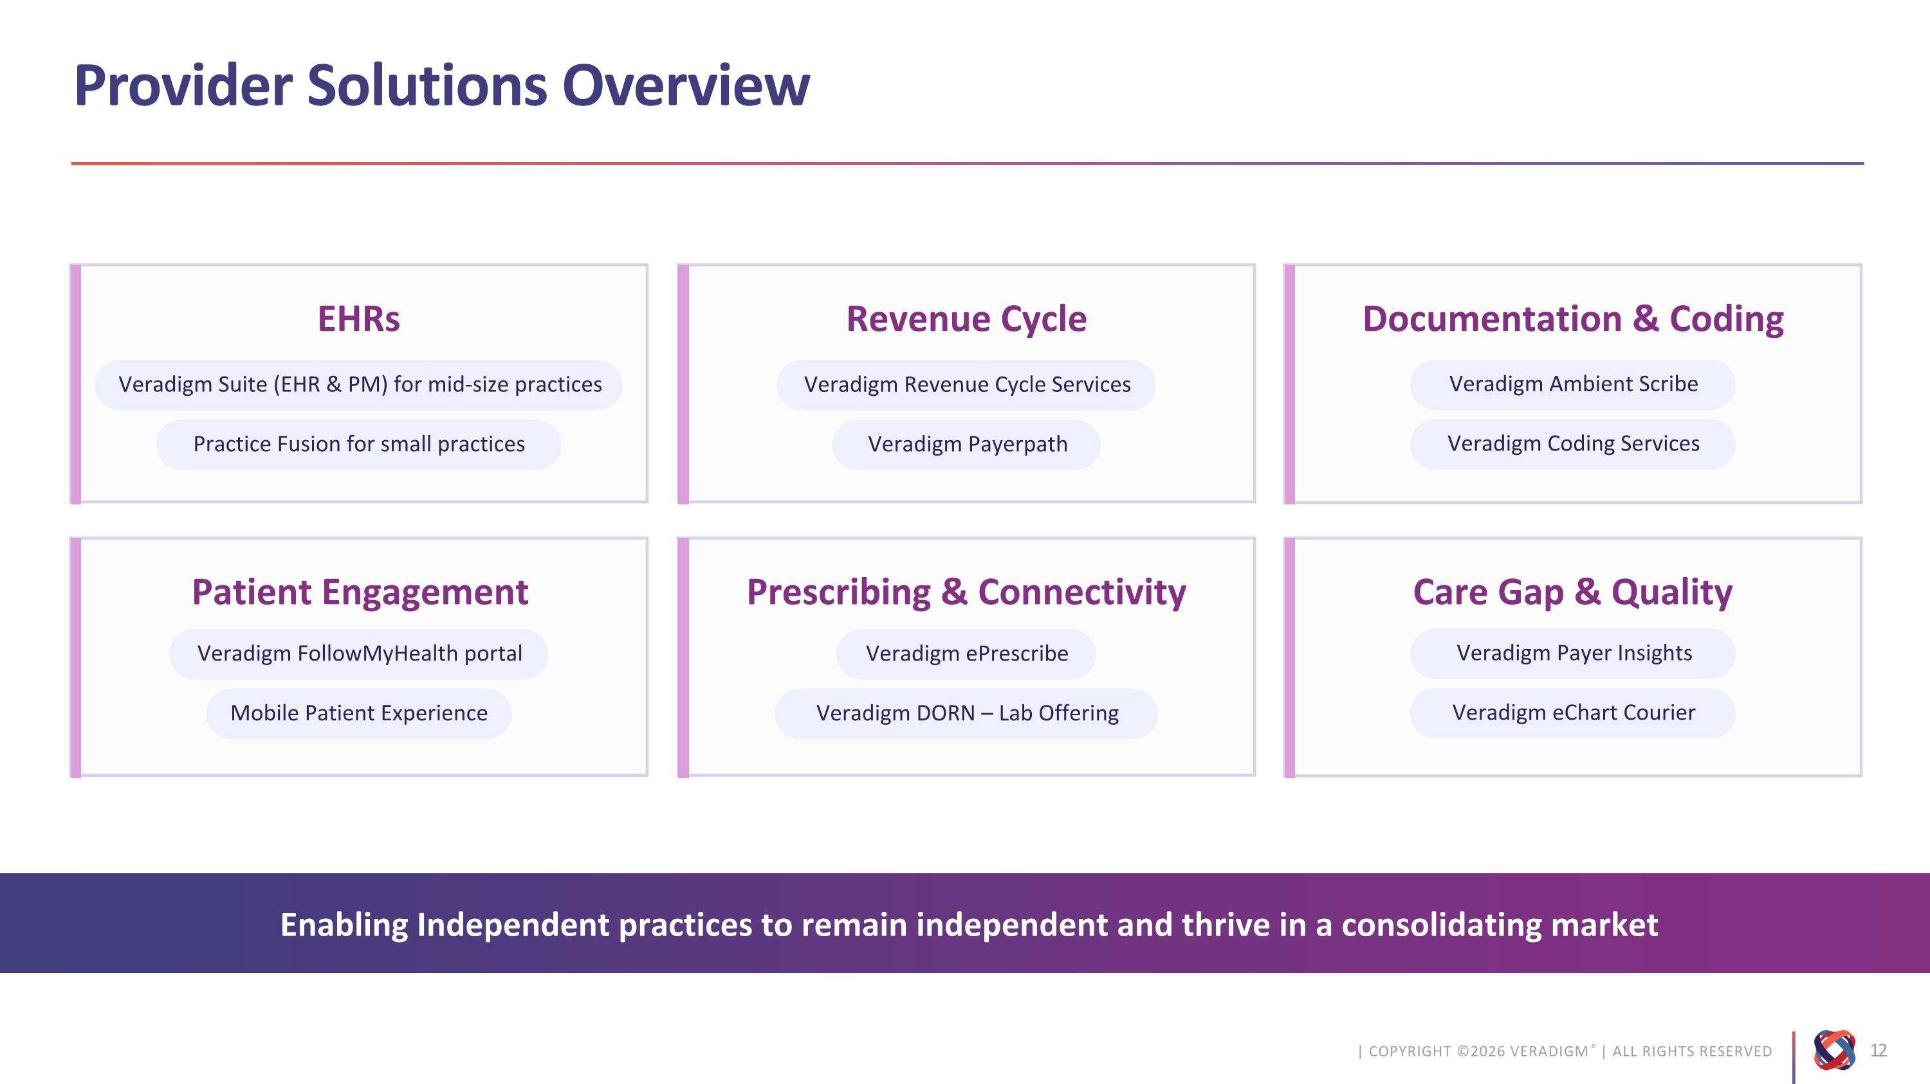
Provider Solutions Overview Enabling Independent practices to remain independent and thrive in a consolidating market EHRs Veradigm Suite (EHR & PM) for mid-size practices Practice Fusion for small practices Revenue Cycle Veradigm Revenue Cycle Services Veradigm Payerpath Documentation & Coding Veradigm Ambient Scribe Veradigm Coding Services Patient Engagement Veradigm FollowMyHealth portal Mobile Patient Experience Prescribing & Connectivity Veradigm ePrescribe Veradigm DORN – Lab Offering Care Gap & Quality Veradigm Payer Insights Veradigm eChart Courier

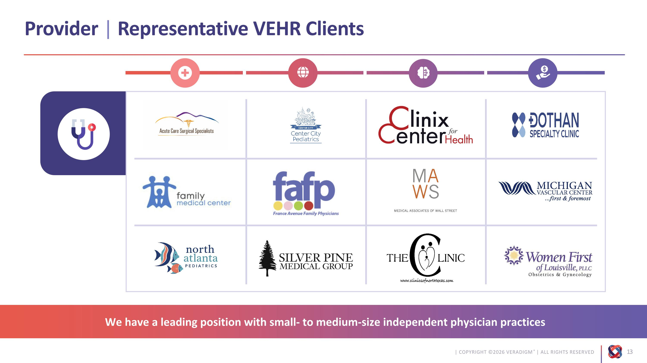
Provider | Representative VEHR Clients We have a leading position with small- to medium-size independent physician practices

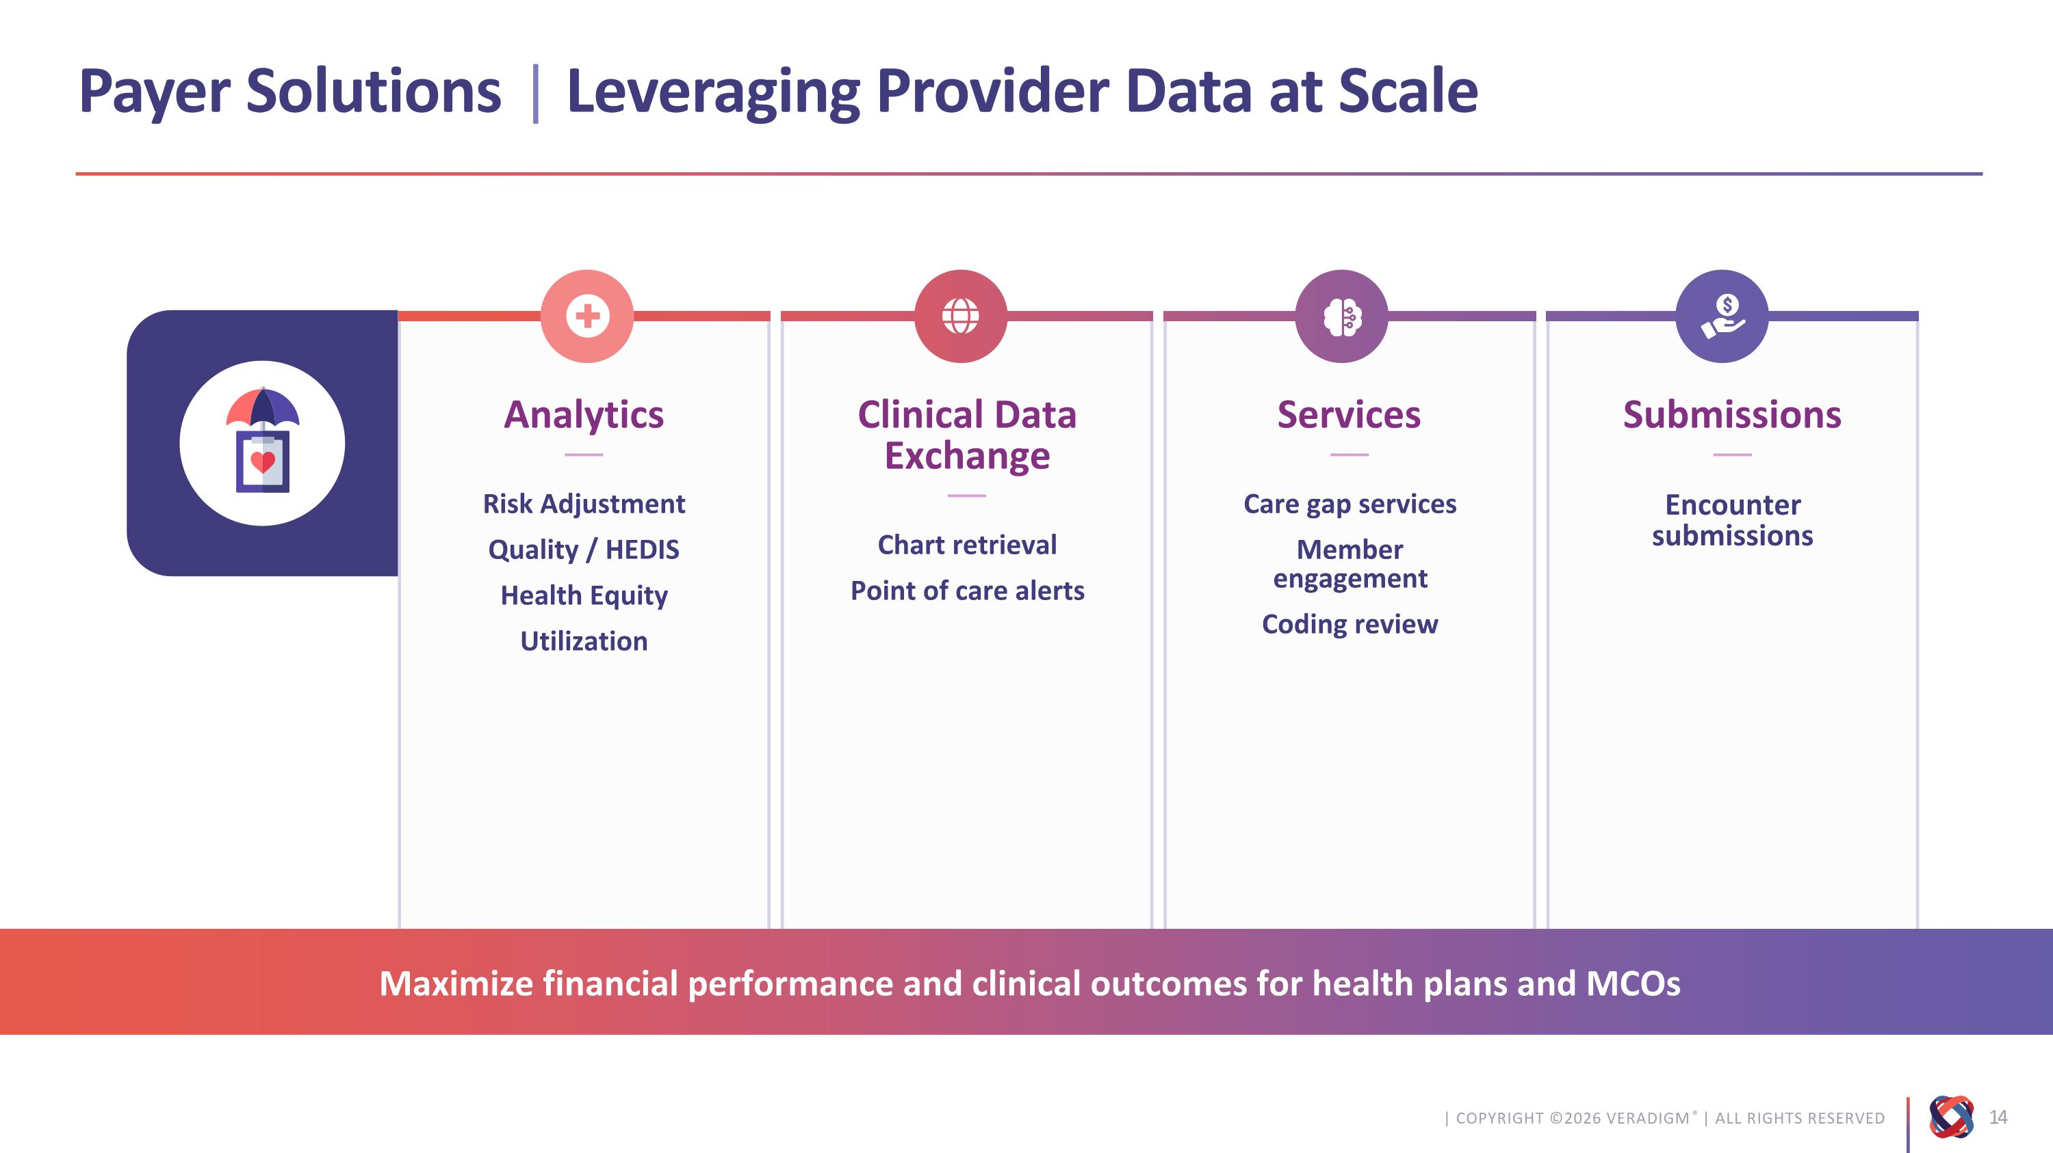
Clinical Data Exchange?–– Chart retrieval Point of care alerts Analytics?–– Risk Adjustment Quality / HEDIS Health Equity Utilization Services?–– Care gap services Member ?engagement Coding review Submissions?–– Encounter ?submissions Payer Solutions | Leveraging Provider Data at Scale Maximize financial performance and clinical outcomes for health plans and MCOs

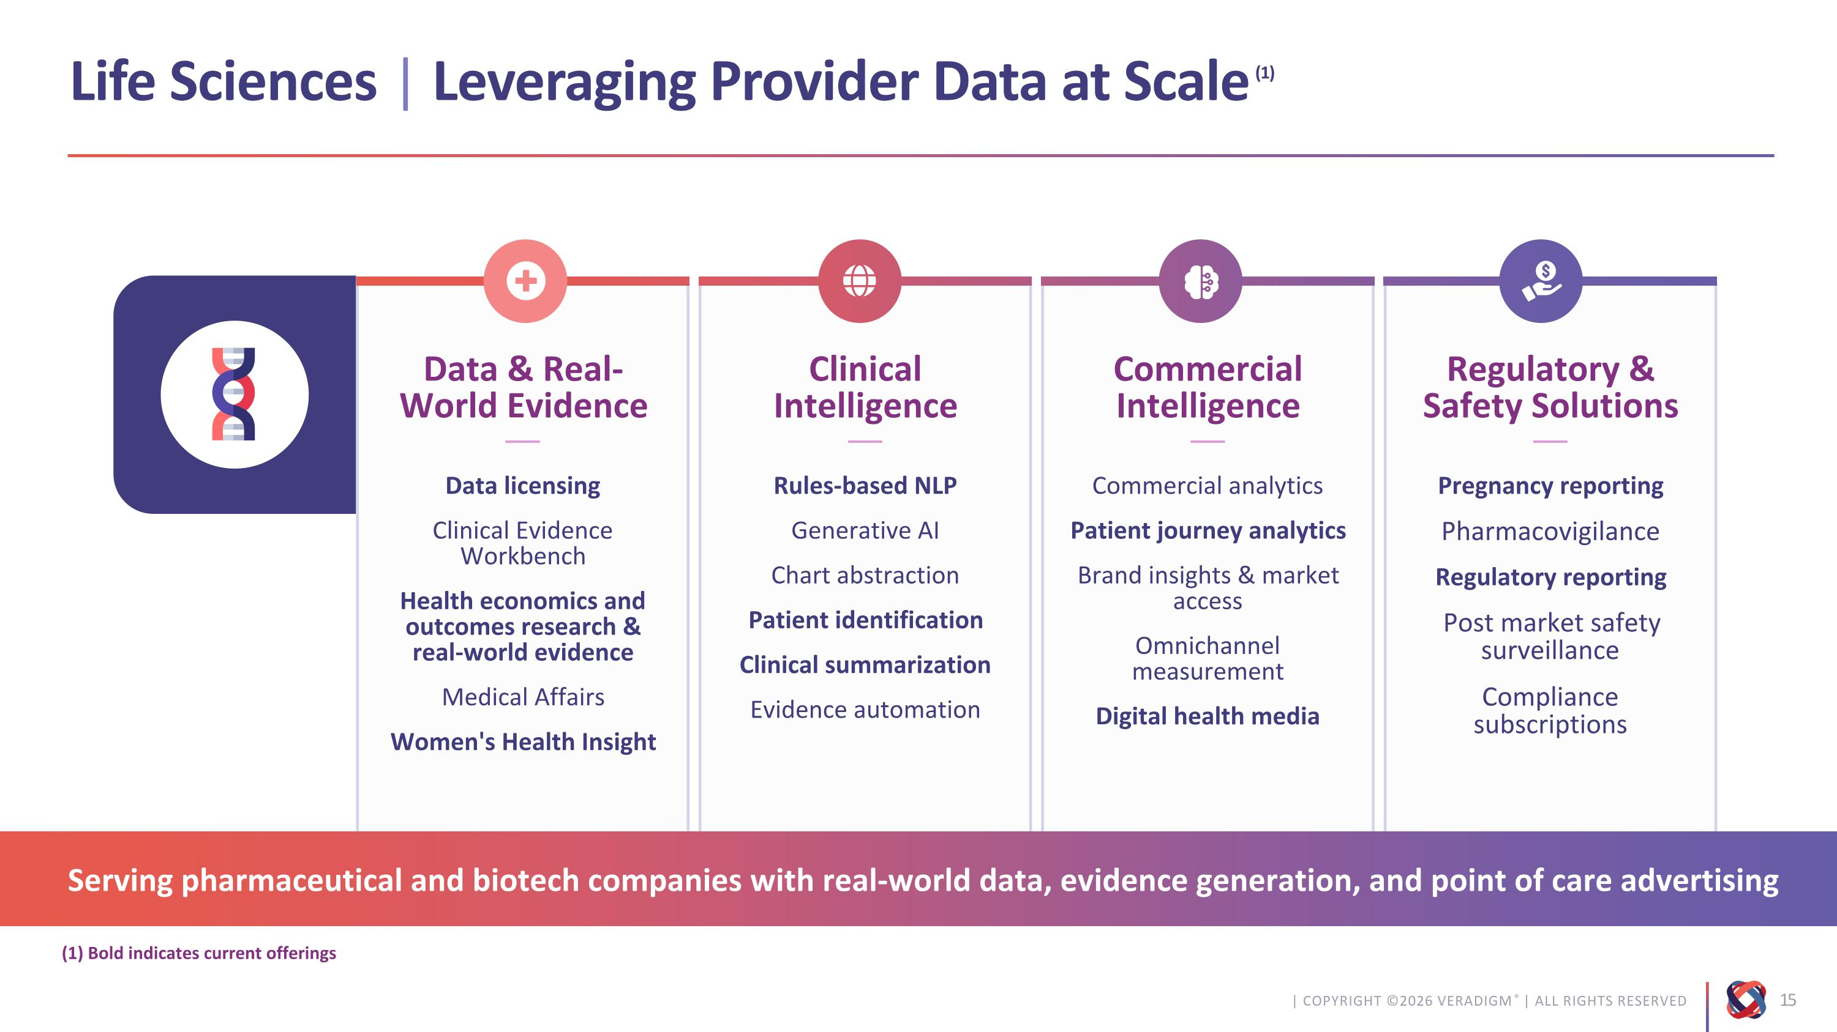
Clinical Intelligence?–– Rules-based NLP Generative AI Chart abstraction Patient identification Clinical summarization Evidence automation Data & Real-World Evidence?–– Data licensing Clinical Evidence Workbench Health economics and outcomes research & ?real-world evidence Medical Affairs Women's Health Insight Commercial Intelligence?–– Commercial analytics Patient journey analytics Brand insights & market access Omnichannel measurement Digital health media Regulatory & Safety Solutions?–– Pregnancy reporting Pharmacovigilance Regulatory reporting Post market safety surveillance Compliance subscriptions (1) Bold indicates current offerings Life Sciences | Leveraging Provider Data at Scale(1) Serving pharmaceutical and biotech companies with real-world data, evidence generation, and point of care advertising

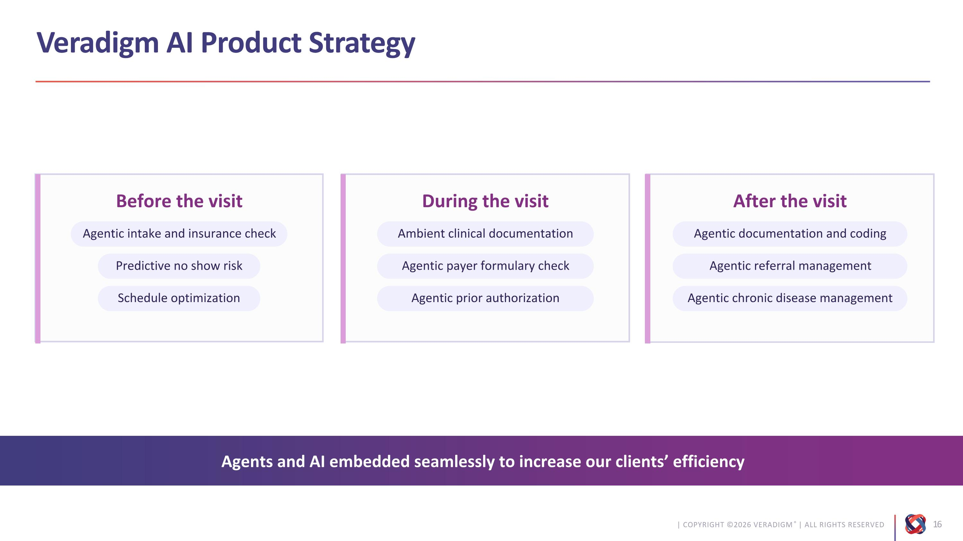
Before the visit During the visit After the visit Veradigm AI Product Strategy Agents and AI embedded seamlessly to increase our clients’ efficiency Agentic intake and insurance check Predictive no show risk Ambient clinical documentation Agentic payer formulary check Agentic documentation and coding Agentic referral management Schedule optimization Agentic prior authorization Agentic chronic disease management

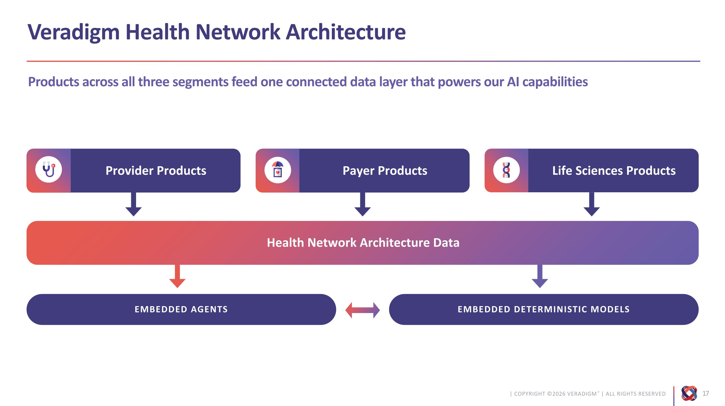
Products across all three segments feed one connected data layer that powers our AI capabilities Health Network Architecture Data EMBEDDED AGENTS EMBEDDED DETERMINISTIC MODELS Veradigm Health Network Architecture Life Sciences Products Payer Products Provider Products

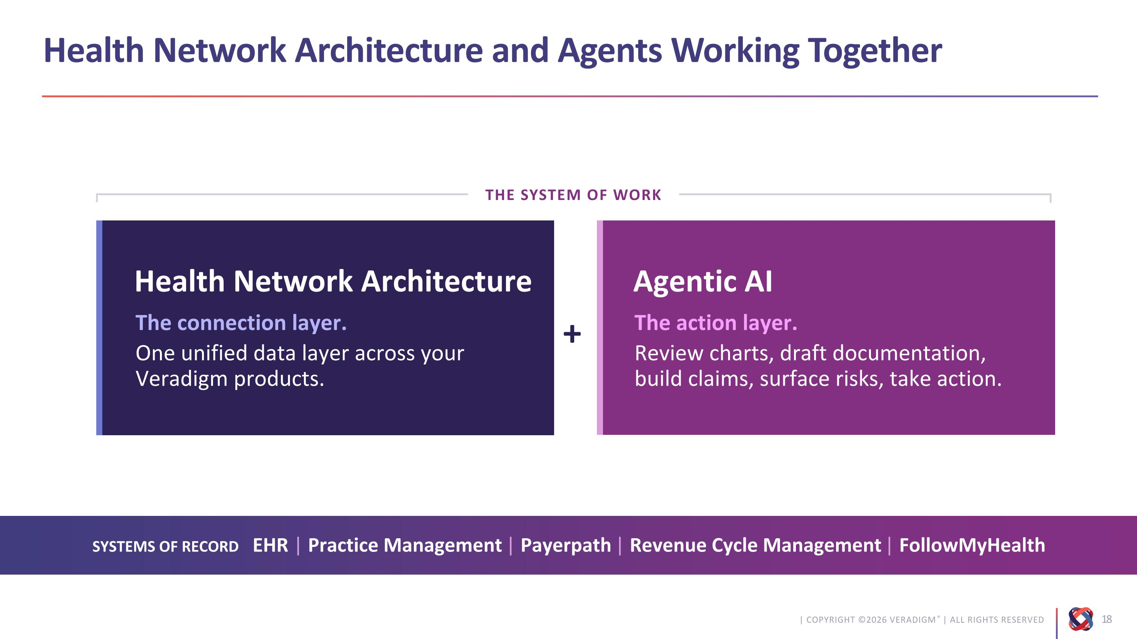
+ Health Network Architecture The connection layer. One unified data layer across your Veradigm products. Agentic AI The action layer. Review charts, draft documentation, ?build claims, surface risks, take action. Health Network Architecture and Agents Working Together SYSTEMS OF RECORD EHR | Practice Management | Payerpath | Revenue Cycle Management | FollowMyHealth THE SYSTEM OF WORK

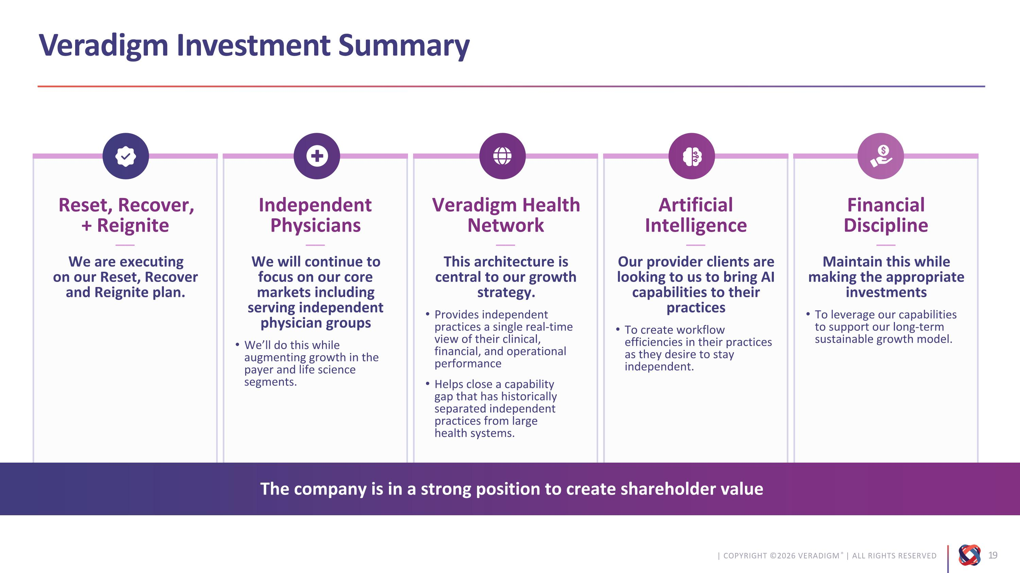
Independent Physicians?––?We will continue to focus on our core markets including serving independent physician groups We’ll do this while augmenting growth in the payer and life science segments. Reset, Recover, ?+ Reignite?––?We are executing ?on our Reset, Recover and Reignite plan. Veradigm Health Network ?––?This architecture is central to our growth strategy. Provides independent practices a single real-time view of their clinical, financial, and operational performance Helps close a capability ?gap that has historically separated independent practices from large ?health systems. Artificial?Intelligence?––?Our provider clients are looking to us to bring AI capabilities to their practices To create workflow efficiencies in their practices as they desire to stay independent. Financial?Discipline?––?Maintain this while making the appropriate investments To leverage our capabilities to support our long-term sustainable growth model. Veradigm Investment Summary The company is in a strong position to create shareholder value



